Parth Babbar

Debit cards

**Introduction:**

Debit cards are a common financial instrument in the United States, acting as the primary way of obtaining funds from checking accounts for daily purchases. They are a handy alternative to carrying cash and give immediate access to users' bank accounts. This article presents an in-depth review of debit card usage in the United States, covering history, functioning, advantages, hazards, and current data.

**History:**

Debit cards were first launched in the US in the 1970s, mostly for ATM transactions. The first ATMs debuted in the late 1960s, and banks immediately recognised the value of cards that could do more than just distribute cash. By the 1980s, debit cards could be used at point-of-sale (POS) terminals, allowing customers to pay directly from their bank accounts. In the 1990s and early 2000s, electronic payment methods were more widely used, reinforcing the importance of debit cards in everyday transactions.

**Functionality:**

Debit cards are plastic payment cards supplied by financial organisations that enable customers to withdraw money directly from their checking accounts. The major functionalities are:

1. **ATM Withdrawals:** Cardholders are able to withdraw cash from ATMs.
2. **Point-of-Sale Purchases:** Debit cards may be used to pay for products and services at retail stores.
3. **Online Transactions:** Many debit cards accept online payments.
4. **Bill Payments:** Debit cards can be used to pay bills directly or via bank-sponsored bill pay services.

**Types of Debit Cards:**

1. **Standard Debit Cards:** Directly linked to the cardholder's checking account.
2. **Prepaid Debit Cards:** These cards are not tied to a bank account and have monies placed onto them.
3. **Bank-Branded Cards:** Banks issue these cards, which bear their logo.
4. **Network-Branded Cards:** Issued by major payment networks such as Visa, Mastercard, and American Express.

**Benefits & Drawbacks:**

**Benefits of Debit Cards:**

1. **Convenience:** Debit cards are simple to carry and use for a range of transactions, providing quick access to funds without requiring cash.
2. **Immediate Fund Access:** They are immediately connected to checking accounts, allowing you immediate access to monies.
3. **Spending Control:** Debit cards aid with financial management by restricting spending to the account's available balance.
4. **Security Features:** PIN protection and EMV chips help guard against theft and fraud.
5. **No Debt Accumulation:** Unlike credit cards, debit cards do not enable spending that exceeds the available balance.
6. **No Interest costs:** Debit cards do not have interest costs because they draw directly from available money.

**Risks & Drawbacks:**

1. **Limited Fraud Protection:** While debit cards do provide some fraud protection, it is often less complete than credit card protection.
2. **Overdraft costs:** If overdraft protection is engaged, transactions that exceed the account balance may result in hefty costs.
3. **Limited Consumer Protections:** Debit cards sometimes offer fewer dispute resolution choices than credit cards.
4. **Potential for Account Drainage:** In the event of theft or fraud, funds can be drained straight from the account, producing rapid financial consequences.

**Trends and Innovation:**

1. **Contactless Payments:** The use of contactless debit cards is growing, with a large surge in contactless transactions during the COVID-19 epidemic.
2. **Mobile Wallets:** Debit card integration with mobile wallets such as Apple Pay, Google Wallet, and Samsung Pay is increasing, driven by customer demand for convenience and security.
3. **Enhanced Security Features:** The use of EMV chips, tokenization, and biometric authentication increases the security of debit card transactions.
4. **Banking applications:** Banks and financial institutions are creating applications that offer real-time transaction notifications and more control over debit card usage.

**Statistics:**

1. **Number of Debit Cards in Circulation:** As of Q4 2023, there were around 944 million debit cards in circulation in the United States, and 2.18 billion debit cards globally. A graph of a graph showing the number of the states and the united states

   Description automatically generated

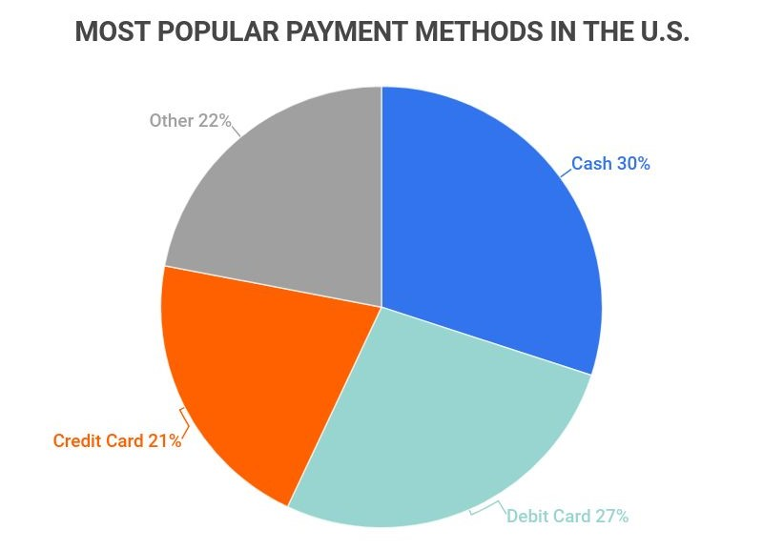

1. **Transaction Volume and Value:** In 2022, debit card transactions accounted for over 70 billion transactions, with a total value exceeding $3 trillion. The average transaction value was approximately $42.

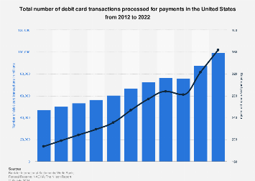

1. **Fraud incidents:** Despite improved security measures, debit card theft has been increasing. Debit card theft caused around $3.7 billion in damages in 2022.
2. **Demographic Insights:** Younger customers (ages 18-34) choose debit cards for everyday purchases because they want direct access to finances and avoid debt. Higher-income families choose credit cards for rewards and credit growth, whereas lower-income households prefer debit cards for greater spending control and debt reduction.

**Regulatory Environment**

The regulatory environment for debit cards in the US is governed by numerous main laws and regulations.

1. **The Electronic Fund Transfer Act (EFTA):** Establishes the rights and duties of consumers and financial institutions in relation to electronic fund transactions.
2. **The Durbin Amendment:** Is part of the Dodd-Frank Wall Street Reform and Consumer Protection Act, caps the interchange fees that banks may charge retailers for debit card transactions.
3. **Consumer Financial Protection Bureau (CFPB):** Responsible for the regulation and enforcement of consumer financial goods, including debit cards.

**Conclusion:**

Debit cards are an important feature of the US payment system, providing convenience and security to customers. While they may have hazards, many users find that the advantages exceed the negatives. Understanding the current landscape and trends can help consumers make more educated payment decisions and financial institutions evolve to suit changing demands.